Preliminary Testing

The Report Generation program is not working. This is a critical function at the end of the template data collection process that generates the .pdf report and stores it to the \app folder (not sure where they are stored).

To replicate:

1. Login in to [WellTrackONE - Welcome](https://www.welltrackone.us/tablet/)
2. UserID: pab, Password: peace4ukraine Client Number: 1 (this is our test Org)
3. Go to Schedule

Click on the 4am appointment on the small clock on the left hand side

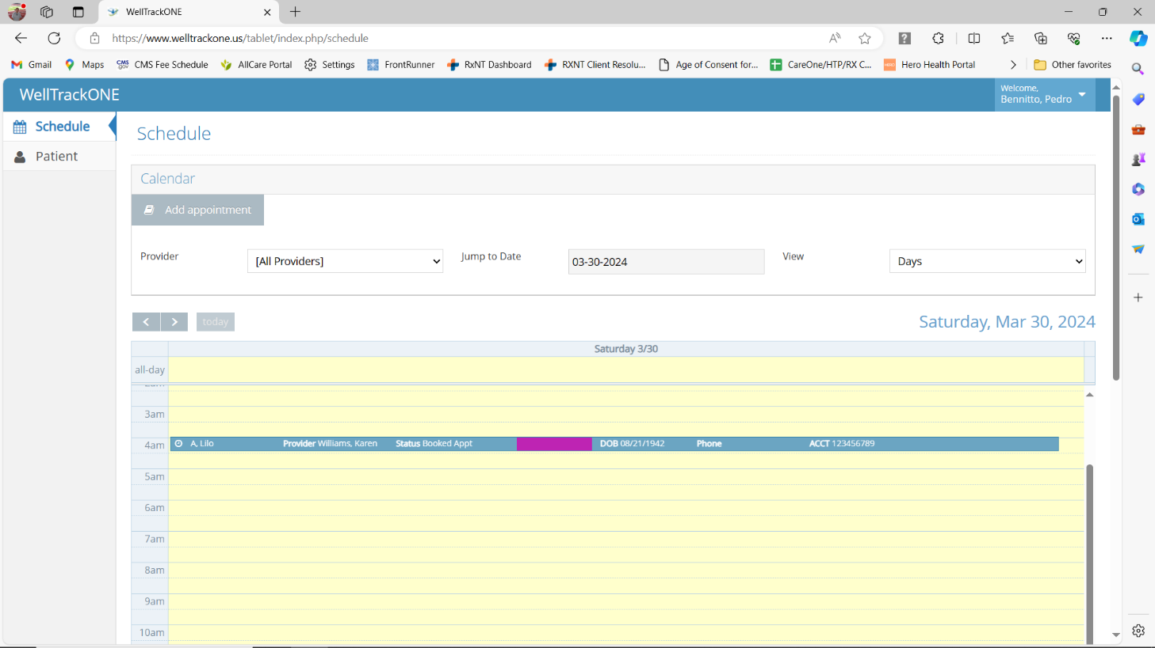

Click on Start Encounter

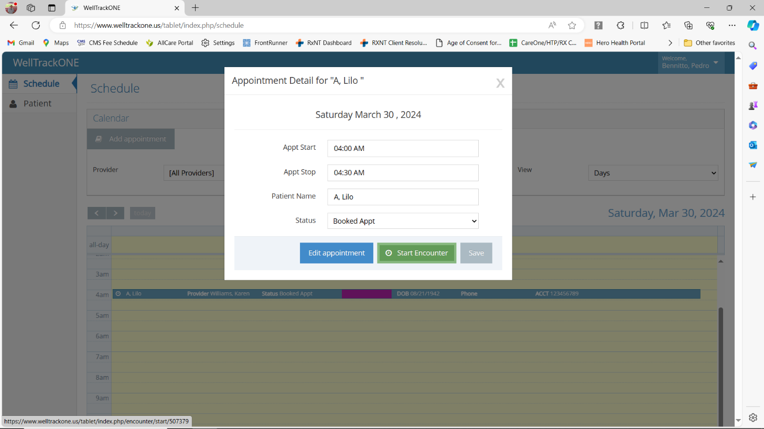

Click on Generate Report

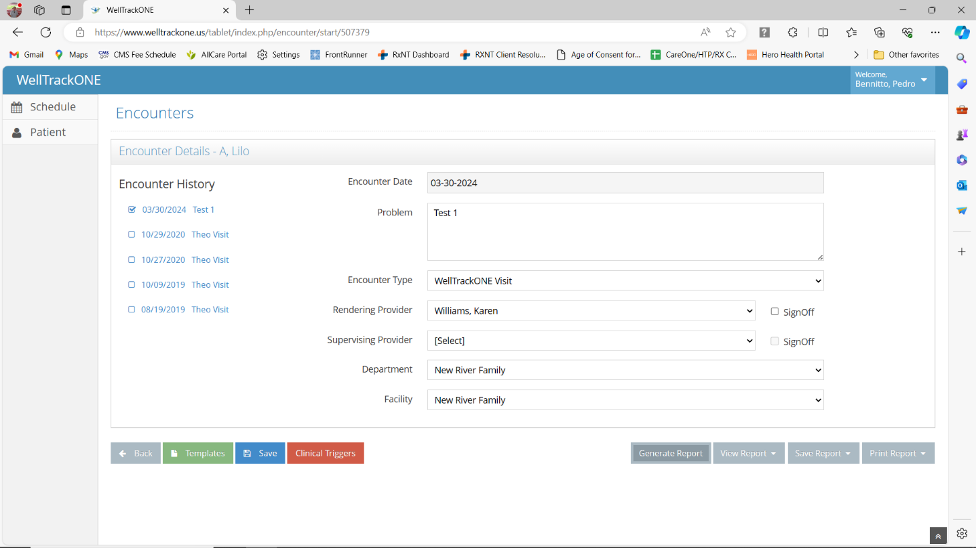

You’ll see that it hangs there and does not generate a report.

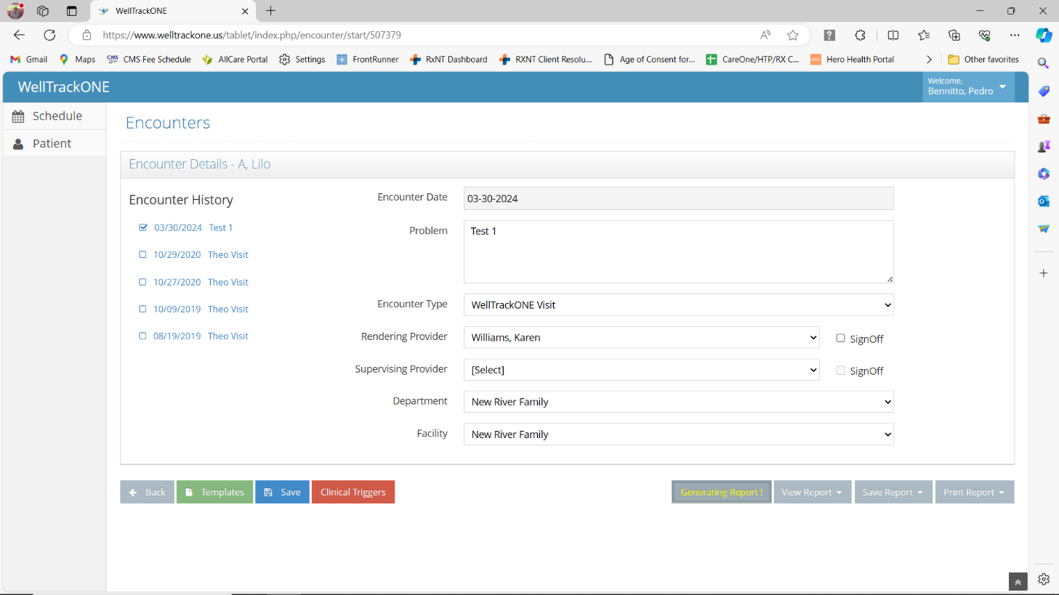

When it is functioning properly, it will allow you to click on View Report/Provider Report

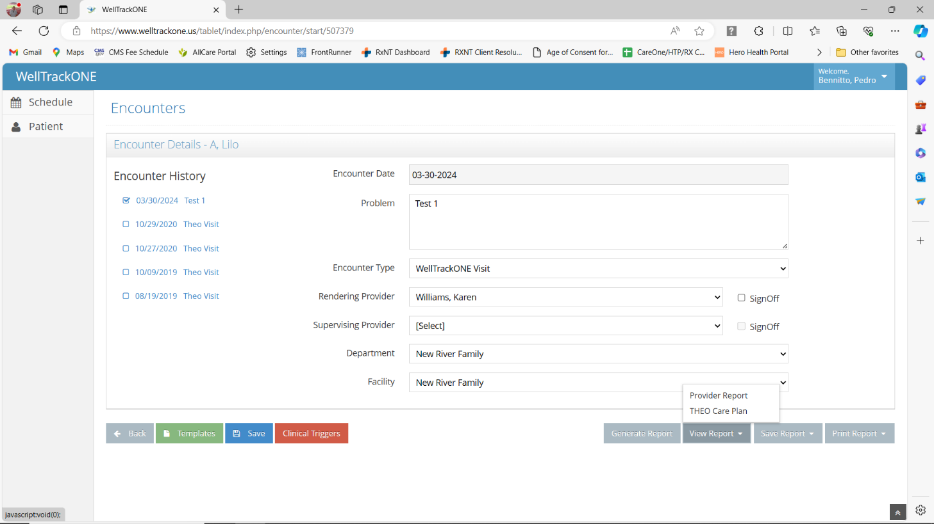

…and you will see the report show up on screen.

**Further Testing on other modules…**

**Welltrackone.us/portal**

If you select “New User” from the opening screen, it switches over to welltrackone.com/portal

**Welltrackone.us/graph**

After you login it switches over to welltrackone.com/graph

Login with pab, peace4ukraine client number 1